Title

First Name, Last Name∗
(School/Institute/Organization), (City/ Town), (Country)

Abstract

Abstract abstract abstract abstract abstract abstract abstract abstract abstract Abstract abstract abstract abstract abstract abstract abstract abstract abstract Abstract abstract abstract abstract abstract abstract abstract abstract abstract Abstract abstract abstract abstract abstract abstract abstract abstract abstract Abstract abstract abstract abstract abstract abstract abstract abstract abstract Abstract abstract abstract abstract abstract abstract abstract abstract abstract Abstract abstract abstract abstract abstract abstract abstract abstract abstract abstract Abstract abstract abstract abstract abstract abstract abstract abstract abstract Abstract abstract abstract abstract abstract abstract abstract abstract abstract Abstract abstract abstract abstract abstract abstract abstract abstract abstract Abstract abstract abstract abstract abstract abstract abstract abstract abstract Abstract abstract abstract abstract abstract abstract abstract abstract abstract. abstract abstract abstract Abstract abstract abstract abstract abstract abstract abstract abstract abstract Abstract abstract abstract abstract abstract abstract abstract abstract abstract. abstract abstract abstract Abstract abstract abstract abstract abstract abstract abstract abstract abstract Abstract abstract abstract abstract abstract abstract abstract abstract abstract.

Keywords: 5 to 6 key words.

Introduction (Subheading if necessary)

(Font Calibri point 11; single line spacing) Write your text here. Write your text here. Please set ‘language’ in the ‘tools’ menu to UK English. Please limit your written version of your paper to 6000 words as an absolute maximum, including footnotes if any. If you are intent on reading your text aloud, please be advised that under normal speaking circumstances, it is only possible to read aloud a maximum of about 3000 words to be legibly heard in 20 minutes. The average word count for commercial audio books is 150–160 words per minute. This is the pace that people are able to comfortably hear vocalized words with understanding. If you are intent on reading your paper, please allow for add pauses and conversational digressions to your verbal delivery. However, it preferred if will not read the paper as written but present it.

You may use footnotes or a list of references or both. But no end notes. …………………………………………………………………………………………………………………………………………………………………………………………………………………………………………………………………………………………………………………..

Theorizing shelter as place:

(Font Calibri point 11; single line spacing) Write your text here. Write your text here. Long quotations should be isolated in indented paragraphs as below.

Ut wisi enim ad minim veniam, quis nostrud exerci tation ullamcorper suscipit lobortis nisl ut aliquip ex ea commodo consequat. Duis autem vel eum iriure dolor in facilisis at vero eros et accumsan et iusto odio dignissim qui blandit praesent luptatum zzril delenit augue duis dolore te feugait nulla facilisi
Rapoport, 1969: 64

………………………………………………………………………………………………………………………………………………………………………………………………………………………………………………………………………………………………………………………………………………………………………………………………………………………………………………………………………………………………………………………………………………………………………………………………………………………………………………………………………………………………………………………………………………………………………………………………………………………………………………….. Use running references in the text as this (Canter, 1977).

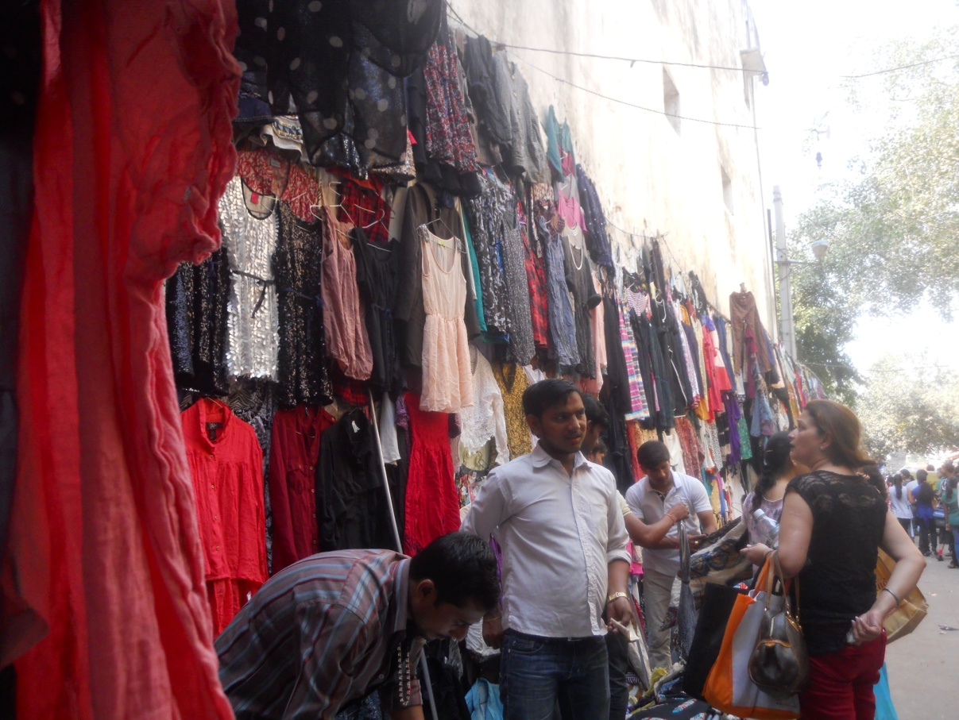
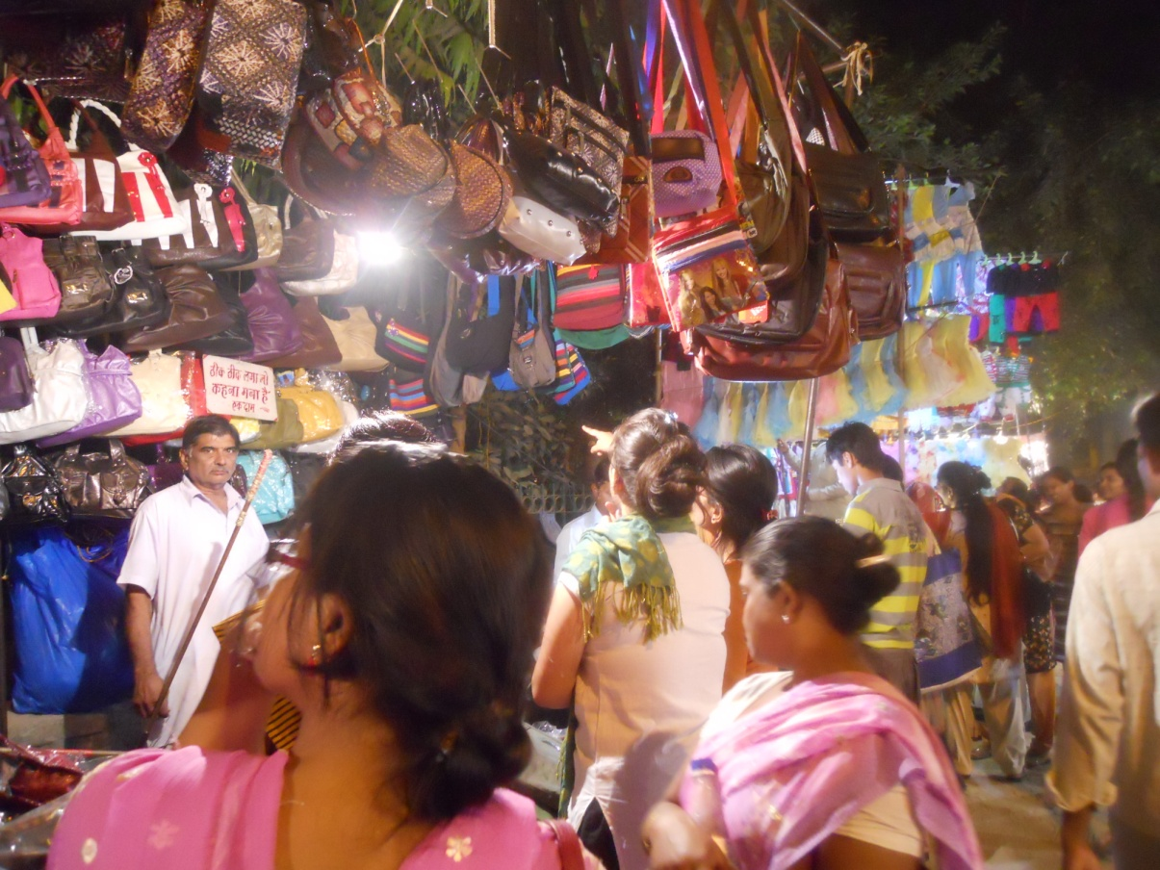
Fig. 1: The Informal market: People-places
Source: author

Each image should have a Figure Number in 10pt bold, ie Figure 1: Insert Title of image, brief description. (source of image as per citation style). Captions should be complete enough to allow understanding of the image without referring to the text. Centre image. Height of all images should be 10cm or less for consistency. Width of image shall be less than or equal to the width of the body text. For captions use Calibri 10pt, single line spacing, centre aligned, justified and indented 2.5cm on left and right margins. Insert two returns after caption. Note: do not insert author/s names in captions. For example, if you are citing an image you created, attribute the work to ‘the author’

Table headings should be sufficient to explain the figure or table without needing to refer to the text. Tables not cited in the text should not be presented. Styles Heading Table and Caption Figure are available in this template for tables and figures. The following is the example for Table 1.
Table 1: Title of Table
Header | dsds | uodesp
Sfsfj jehioad rohidq | 3 | fedsa
Kgdsieo fjsjfsks | 2 | updios
dfrghghth | 2 | sdsteg

Tables should be placed close after their first reference in the text. All figures and tables should be numbered with Arabic numerals. Table headings should be centred above the tables. Figure captions should be centred below the figures.

References:

Book – single author / multiple authors:
Jones, B. (1995) Sleepers, wake!: technology and the future of work, 4th edn, Melbourne: Oxford University Press.

Stein, B. & Reynolds, J.S. (2000) Mechanical and electrical equipment for buildings, 9th edn, New York: John Wiley & Sons.

Book chapter:
Crawford, R.J. (1998) 'Plastics available to the designer', in Plastics engineering, 3rd edn, Oxford:Heinemann-Butterworth. pp. 6-18.
Edited book:

Muller, J. Cloete, N.& Badat, S. (2001) Challenges of globalisation: South African debates with Manuel Castells, Cape Town: Maskew Miller Longman.

Journal article:
Zivkovic, B. & Fujii, I. (2001) 'An analysis of isothermal phase change of phase change material within rectangular and cylindrical containers', Solar Energy, Vol. 70, no.1, pp. 51-61.

e-journal article from a database:
Easthope, G. ( 2004) 'Consuming health: the market for complementary and alternative medicine', Australian Journal of Primary Health, Vol. 10, no. 2, pp. 68-75, viewed 30 March 2005, Australian Public Affairs Full Text.

Newspaper article:
Tobler, K. & Kerin, J. (2002) ‘Hormone alert for cancer’, The Australian, 10 July, p. 1.
Note: if the newspaper article does NOT have an author then provide details as an in-text citation only, NOT in the Reference List. For example: The Australian (10 July 2002, p.1) states……

Website documents:
United Nations, (2007) Universal declaration of human rights, United Nations, viewed 19 March 2007, http://www.un.org/Overview/rights.html.

Conference paper:
Kovacs, G.L. (1994) ‘Simulation-scheduling system using hybrid software technology’, in Computer Integrated Manufacturing and Automation Technology: Proceedings of the 4th International conference, New York: Troy, October 10-1, pp.164-189.,

 Corresponding Author: Xxx Yyy Zzz; E-mail- xxxyyyzzz@yahoo.com
Use footnotes or list references at the end in the following style Oliver, P (1985) Shelter Sign and Symbol, London: Barrie & Jenkins, pp. 173
Use footnotes or references in the following style Oliver, P. (1985) Shelter Sign and Symbol, London: Barrie Jenkins, pp. 173

